**Practical 7: Build Your DB Server and Interact With Your DB Using an App**

**Solution:**

Step 1. Go to AWS dashboard, search and select **VPC**

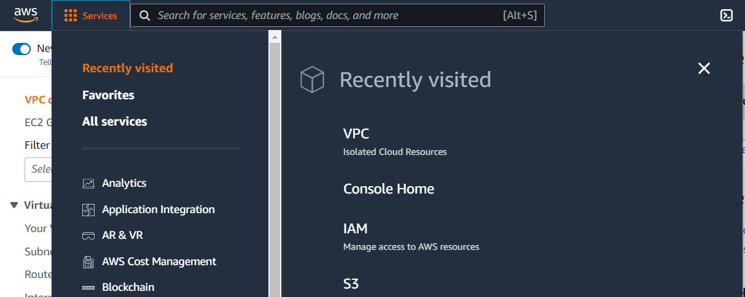

Step 2 : In the left navigation pane, choose Security Groups.

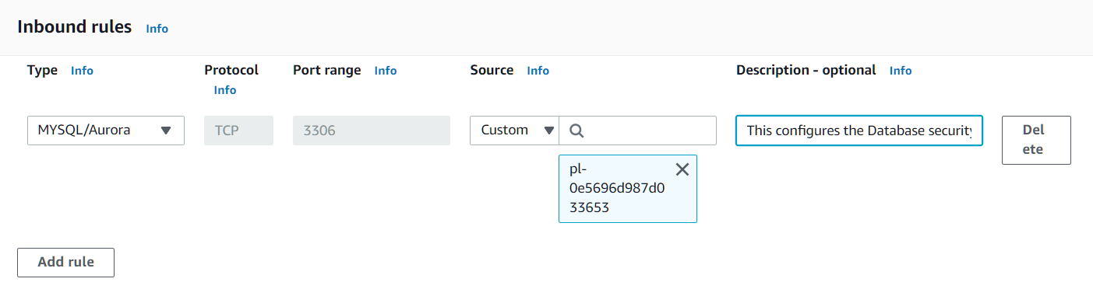

Step 3: Click the button at bottom “create security group”

**Task 2: Create a DB Subnet Group**

Step 1: On the Services menu, choose **RDS**

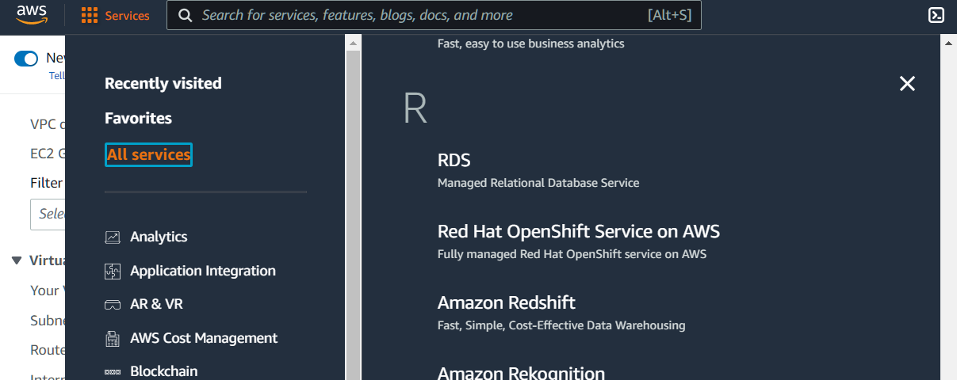

Step 2: In the left navigation pane, choose **Subnet groups**.

